Clothing Virtual Try-On

Jorge Olivares

Robin Martinez

Alan Vela

**Concept of Operations**

REVISION - Draft

06 February 22

Concept of Operations

for

Clothing Virtual Try-On

Team <38>

Approved by:

_____________________________

Jorge Olivares Date

_____________________________

Prof. Kalafatis Date

_____________________________

Skyelar Head Date

**Change Record**

|  |  |  |  |  |
| --- | --- | --- | --- | --- |
| **Rev.** | **Date** | **Originator** | **Approvals** | **Description** |
| **0** | [02/1/22] | [Jorge Olivares]  [Alan Vela]  [Robin Martinez] |  | Draft Release |
| **1** | [02/6/22] | [Jorge Olivares]  [Alan Vela]  [Robin Martinez] |  | Revision 1 |

**Table of Contents**

**Table of Contents 3**

**List of Tables** **4**

**No table of figures entries found. 4**

**List of Figures 5**

**No table of figures entries found. 5**

**1.** **Executive Summary 5**

**2.** **Introduction 6**

2.1.1 Background 6

2.1.2 Overview 6

2.1.3 Referenced Documents and Standards 7

**3.** **Operating Concept 8**

3.1.1 Scope 8

3.1.2 Operational Description and Constraints 8

3.1.3 System Description 8

3.1.4 Modes of Operations 9

3.1.5 Users 9

3.1.6 Support 9

**4.** **Scenario(s) 10**

4.1.1 Clothing Retail Industry 10

4.1.2 Personal Use 10

4.1.3 Virtual Reality 10

**5.** **Analysis 11**

5.1 Summary of Proposed Improvements 11

5.2 Disadvantages and Limitations 11

5.3 Alternatives 11

5.4 Impact

**List of Tables**

No table of figures entries found.

**3**

**List of Figures**

# Fig. 1 System Overview

# Executive Summary

The Internet is a great tool that has provided a great number of innovations. Online shopping is a big part of it; however, it does create an issue. People don’t get to have a personal look at the object they are purchasing leading to dissatisfaction with the product when it finally arrives and then returning it. This cycle affects the apparel market heavily because Americans tend to return 10% of their purchases, but in apparel, 35% of products get returned. For companies, this is money being lost and environmentally it creates waste.

We are going to implement an application that is accessible to all public and helps reduce the quantity of returns done by customers shopping for clothes. The application is going to take a recording of the user. Once the video is uploaded, our application will create a 3D model of the user. This model is able to change the clothing that it has on, therefore we are able to create an opinion of how an outfit would look on us. Now that we are able to create a criterion of how clothes look on the customer without purchasing, people are going to make shopping decisions more accurately. We believe that this will help reduce the amount of returns.

# Introduction

In this document we are going to introduce the Virtual Clothing Try-on project. This project is going to be an application that has a wide range of utilities. Its versatility comes from the use of a simple RGB camera that is compatible with augmented reality. The camera is going to take a video recording of a user and turn it into a 3D model. Moreover, we are going to use the model to try-on different sets of clothing. Also, we are creating a database that will contain different clothing designs for all genders. In the very end, it will help with the reduction of returns to retail.

## Background

Currently the process to verify that clothes fit is physically trying the clothes on. This process is not very efficient since it has a waiting time that can vary from a pair of days to even a month for clothing to arrive if bought overseas. This costs time for the customer and money to the company when the product is returned. Our main goal is that the application will allow for the customer to have a preview of the clothing on them and allow for a more informed decision when purchasing.

## Overview

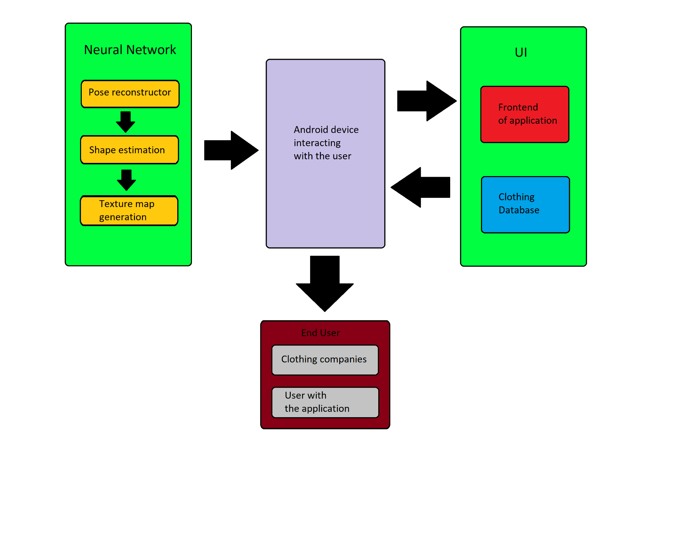

Fig. 1 System overview

In order for the application to work we decided to divide the system into two areas. The first area will be the neural network which is going to take care of the heavy lifting for the application. This neural network will process the video information. Once the information is processed by the system we will have a 3D model that will be stored on the android phone.

The second area of our system is the UI. This will be interacting with both the neural network system and the user. One area that will be interacting directly with the user is the front end, therefore we have to give a comfortable environment for the user. We want to ensure the user’s enjoyment when using the application. Another area of the UI is the back end. This area is mainly in charge of the database containing different clothing designs. Nevertheless, it will aid with the proper transfer of information between the neural network and the front end of the application.

## Referenced Documents and Standards

* Alldieck,Thiemo;Magnor,Marcus;Xu,Weipeng;Theobalt,Christian;Pons-Moll,Gerard “Video Based Reconstruction of 3D People Models”
* https://www.mckinsey.com/industries/retail/our-insights/returning-to-order-improving-returns-management-for-apparel-companies

# Operating Concept

## Scope

The Clothing Virtual Try-on application proposed in this document was designed to allow customers to freely choose clothing on a 3D model of themselves and get an opinion of how the clothes will look on them before purchasing. The customer will be able to choose between a selection of clothing having different designs, sizing, and colors of which they can see how it looks on their 3D model. This will help customers reduce the amount of returns when purchasing clothing.

## Operational Description and Constraints:

Clothing Virtual Try-on application is intended to be used for people who shop online and companies that want to advertise their clothing. Several selections of clothing will be displayed for the user to choose from and will be projected on their 3D model. The user will be able to select clothing they are satisfied with and purchase it on the application.

The application must meet all the following criteria:

* The user must have an android AR compatible phone
* User must use backend camera for video
* User must use clothing that is fitting
* User privacy. Software side of the program must be able to handle 3D Model data without transmitting personal information
* The video needs to be at least a 24 fps, 30 second video that is colored

## System Description

Our Clothing Virtual Try-on clothing application will consist of three main subsystems: the front end, backend, and neural network.

**Front End**: This is the main subsystem that will include the user interface (UI). This is the aesthetic area of the application of which the user will see. This will allow the user to interact with the application on their phone. The UI enables display customization such as view objects that the user can interact with. This will include buttons and textboxes.

**Back end**: The back end of the application will be interacting with both the main UI to receive the information from the video recording and the neural network to process the information. However, the most important part is going to be establishing the database with the catalog of different clothing the model can change into.

**Neural Network**: Using a monocular RGB video of a person moving, a 3D model of them would be created. The neural network normalizes the videos data to 24 fps and a certain resolution. The model then does semantic segmentation in each frame to isolate the person into parts such as arms, legs, torso, etc. From there a skeleton is generated using preexisting work. The neural network model then generates textures onto the skeletal model. Finally, clothing textures taken from the clothing database are applied onto the 3D model.

## Modes of Operations

The Clothing Virtual Try-on application will have a primary mode of operation when the user opens the application on the phone. In this mode, the user will use the backside camera of their android phone and upload a video to the application. The collected data from the user will be used to construct a 3D model of themselves via the Virtual Clothing Try-On neural network. With this model and the selection of clothing stored in our database, the user is presented with a model of themselves having a variety of different clothing to choose from.

The application will also have an error notification system where it would output a message to the user in the event of a problem that occurs within the database, internet speed, or simply the application itself. This will allow for the application to not all crash and let the user know when something is wrong to try again later.

## Users

Our Clothing Virtual Try-on application will be marketed to people of all ages, but that mostly shop online. This will allow for customers to be more comfortable shopping for clothing online as well as mitigate the need to return clothes after unsatisfactory purchases.

Our application can be also marketed to clothing companies that would want to implement their clothing using the application. This will create a great way of advertising their clothing and getting more purchases without the loss of money from returns.

## Support

Support for the Clothing Virtual Try-on application will be provided on the application itself. This will include instructions on how to use the application, a video example of how to video record yourself for the 3D model using the back camera, and tech support to be able to contact.

# Scenario(s)

## Clothing Retail Industry

The Clothing Virtual Try-On app will find its main use in the clothing retail industry scene. The app would allow companies such as Amazon to advertise clothes from their catalog to customers. This would eliminate the loss produced by customers returning clothing to their retailers.

Manufacturers of clothes and established brands can also use the app to advertise upcoming clothing lines.

## Personal Use

The Clothing Virtual Try-On app could also be configured for personal use. Users would be able to store 3D models of all their articles of clothing in their wardrobe in a server. This would allow them to mix-and-match clothing and envision outfits they would like to wear for the day. Time wasted from trying on different outfits would be removed from the morning.

## Virtual Reality

Using augmented reality from an application can help companies use virtual reality by using the 3D models created by the neural network. Companies such as Metaverse could use the data from the neural network to personalize models for individual users. This would allow more flexibility for the users to create an avatar that resembles themselves.

# Analysis

## Summary of Proposed Improvements

The Clothing Virtual Try-On app will provide improvements such as:

* Easier access to clothing catalogs of retail stores
* Less returns on unsatisfactory sales
* Sell upcoming line, allow for pre ordering on clothes

## Disadvantages and Limitations

The Clothing Virtual Try-On app will have limitations that include:

* Only works on android phones with ARCore compatibility
* 3rd party GPU sources must be used to train the model
* The video needs to be at least a 24 fps, 30 second video that is colored

## Alternatives

Some alternatives to the Clothing Virtual Try-On app are:

* Conventional shopping and trying on clothes in store
* Stores with lenient return policies that reduce loss from returns

## Impact

If the app were to be successful this would have a major impact on the clothing retail scene. There have not really been successful applications for the construction of personalized 3d models and applying textures onto said models. Clothing chains would be able to retain a bigger audience for their product as they would be able to easily advertise their merchandise.

There would be privacy and security concerns in regards to the manner in which these personalized models are stored. Questions would be raised on the rights to these models.